**HORMISDALLEN SCHOOL - KYEBANDO**

**PRE-PLE SET 6 EXAMINATION, 2023**

**PRIMARY SEVEN SCIENCE**

Duration: 2 Hours 15 Minutes

**NAME: ____________________________________________STREAM: _________**

EMIS NO.

INDEX NO.

**SECTION A (40 MARKS)**

1. Name any one item a P.7 child can use to keep his or her body clean. ___________________________________________________________________
2. Which part of air is needed during charcoal burning?

___________________________________________________________________

1. How does immunization help to keep the respiratory system healthy? ___________________________________________________________________

***The diagram below shows a certain solar equipment. Use it to answer questions 4 and 5.***

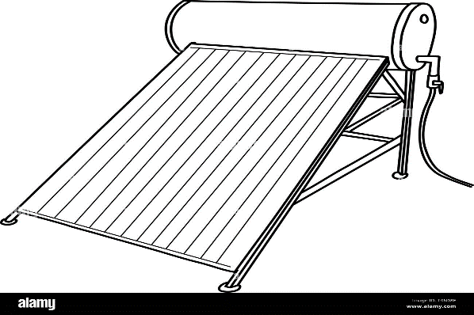

1. Name the above solar equipment.

___________________________________________________________________

1. State the use of the above equipment.

___________________________________________________________________

1. Why is the above solar equipment put in an open space?

___________________________________________________________________

1. P.6 children are fond of running unnecessarily in the school compound. How is such a habit dangerous to their lives? ___________________________________________________________________
2. Besides meat, mention any one other product people obtain from rabbits. ___________________________________________________________________
3. Give one way of controlling the spread of COVID-19 in our school. ___________________________________________________________________
4. Bees sting people, in which one way are bees useful to people? ___________________________________________________________________
5. Which sense enables a P.6 child detect the smell of a ripe jackfruit hidden in a bush? ___________________________________________________________________

***The diagram below shows one of the ways of controlling certain diseases. Use it to answer questions 12 and 13.***

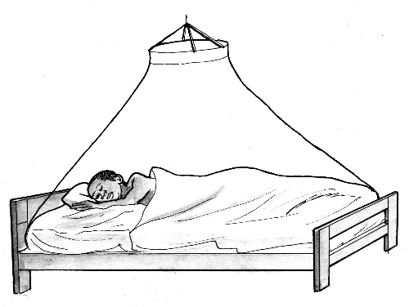

P

1. Name item marked P. ___________________________________________________________________
2. Name any one disease controlled by the practice above. ___________________________________________________________________
3. Why is part P made with very small holes? ___________________________________________________________________

***The diagram below shows an activity done by farmers after harvesting crops. Use it to answer questions 15 and 16.***

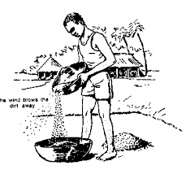

1. Name the activity shown in the diagram. ___________________________________________________________________
2. Which form of energy enables a farmer to carry out the activity shown above? ___________________________________________________________________
3. State any one way in which bones are important to the circulatory system. ___________________________________________________________________
4. How is the dumping of plastics onto the soil harmful? ___________________________________________________________________
5. State one way in which the mode of movement of a fish is similar to that of a tadpole. ___________________________________________________________________
6. Name the solvent used in the preparation of ORS. ___________________________________________________________________
7. Besides houseflies, give any one other organism that moults. ___________________________________________________________________
8. Which part of a sugarcane plant is eaten by people? ___________________________________________________________________
9. A stone and a feather were dropped from a certain height. Which object reached the ground first? ___________________________________________________________________
10. Give a reason to support your answer in (23) above. ___________________________________________________________________
11. James shares a living house with his farm animals. How is such a practice harmful to James’ family? ___________________________________________________________________
12. How is tobacco smoking harmful to the respiratory system? ___________________________________________________________________
13. Name any one vector disease caused by worms. ___________________________________________________________________

***The diagram below shows a man giving first aid. Use it to answer question 28 and 29.***

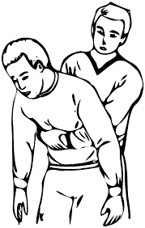

1. Identify the accident in which the above First Aid is applied. ___________________________________________________________________
2. How do people avoid such accidents in 28? ___________________________________________________________________
3. How are mittens important in control of burns at home? ___________________________________________________________________
4. Imagine you are the health prefect of Namirembe P/S. State any one activity you can do to promote the health of children at your school. ___________________________________________________________________
5. State any one-way rubbish can be managed on your school compound. ___________________________________________________________________
6. How can an individual prevent the bacteria that cause tooth decay? ___________________________________________________________________
7. What first aid can you give to a person with a scald in the face? ___________________________________________________________________
8. State any one way of managing strong wind in the school compound. ___________________________________________________________________
9. Give one reason why we take drugs. ___________________________________________________________________
10. Which body organ enables a P.6 student recall what was taught to him or her in P.3? ___________________________________________________________________
11. Give the importance of quill feathers found on the wings of a flight bird. ___________________________________________________________________
12. ***In the space below, draw and name any one garden tool used to harvest root crops.***

|  |
| --- |
|  |
|  |

1. Why do you think houses in deserts are painted white? ___________________________________________________________________

**SECTION B (60 MARKS)**

1. **The diagram below shows a certain symbol used in management of nonrenewable resources. Use it to answer questions that follow.**



1. What does the above symbol represent? ________________________________________________________________
2. Why are people encouraged to do the above practice in 41(a)?. ________________________________________________________________
3. Mention any one material which can be passed in the above process in 41(a). ________________________________________________________________
4. Why are people encouraged to conserve endangered species? ________________________________________________________________
5. ***Below is a list of organisms. Use it to answer questions that follow.***

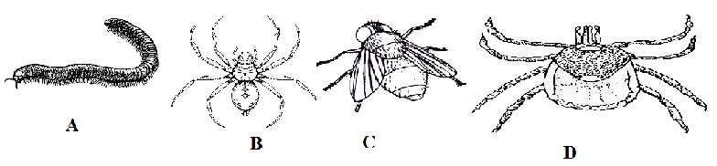

1. Which two organisms can be grouped together in the list above. ________________________________________________________________
2. Give a reason for your answer in a) above. ________________________________________________________________
3. Identify one organism in the environment that can be grouped together with organism A. ________________________________________________________________
4. To which group of arthropods would you classify the above organisms?

________________________________________________________________

1. ***Water borne diseases are diseases which are spread through drinking contaminated water.***
2. Which waterborne disease is characterized by blood-stained diarrhoea? ________________________________________________________________
3. Besides the disease mentioned in (a) above, mention two other examples of water borne disease.
4. ___________________________________________________________
5. ___________________________________________________________
6. State the best way of controlling water borne diseases. ________________________________________________________________
7. ***The diagram below shows how biogas is produced. Use it to answer questions that follow.***

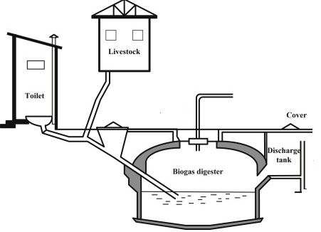

1. Identify any one material used in making of biogas? ________________________________________________________________
2. How do crop farmers benefit from the above process? ________________________________________________________________
3. Why is the biogas digester buried under the ground? ________________________________________________________________
4. Why does NEMA encourage people to use biogas?

________________________________________________________________

1. ***Match vitamins to their function in the body.***

|  |  |
| --- | --- |
| **List A** | **List B** |
| Vitamin K | improves sight | |
| Vitamin D | helps in blood clotting | |
| Vitamin A | helps in prevention of scurvy | |
| Vitamin C | helps in absorption of calcium by the body. | |

1. Vitamin K ___________________________________________________
2. Vitamin D __________________________________________________
3. Vitamin A ___________________________________________________
4. Vitamin C ___________________________________________________
5. a) Give the meaning of the term immunity. __________________________________________________________________

b) State any one way your father can gain natural immunity. __________________________________________________________________

c) How are the following vaccines administered?

1. BCG Vaccine _______________________________________________
2. DPT Vaccine _________________________________________________
3. ***Below is a diagram of a certain latrine. Use it to answer questions.***

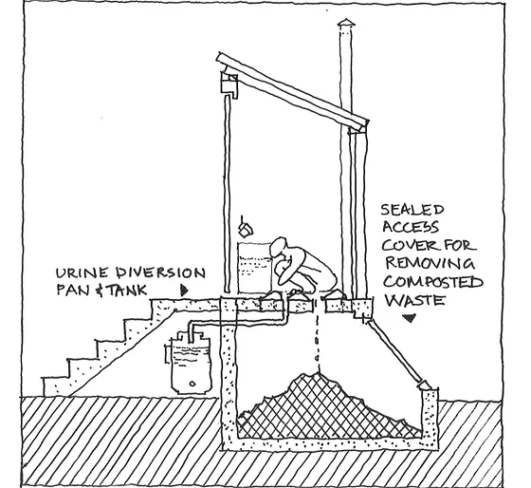

1. Name the above latrine. ________________________________________________________________
2. State the role of a vent pipe on the above latrine. ________________________________________________________________
3. Why is ash needed in maintenance of the above latrine? ________________________________________________________________
4. Why is the above latrine suitably used in swampy areas?

________________________________________________________________

1. a) Give the meaning of the term air pollution. ______________________________________________________________________________________________________________________________________

b) State any one cause of air pollution. ___________________________________________________________________

c) Mention one way of conserving petroleum. ___________________________________________________________________

d) In which one way can untreated industrial wastes be dangerous to water sources? ___________________________________________________________________

1. What term do we use to refer to steps taken to promote public cleanliness?

___________________________________________________________________

b) State any one reason why people are advised to promote public cleanliness in their communities. ___________________________________________________________________

c) Mention any two activities people can carry out to promote public cleanliness. ___________________________________________________________________

___________________________________________________________________

1. ***The diagram below shows a certain human activity. Use it to answer questions that follow.***

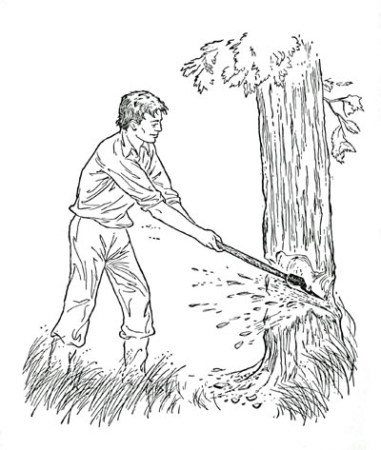

1. Name the tool used by the man to carry out the above activity.

_______________________________________________________________

1. Why do you think the man is carrying out the above activity? Give two reasons.
2. __________________________________________________________
3. __________________________________________________________
4. State any one danger of the above activity to the environment.

________________________________________________________________

1. a) Name the digestive juice produced in each of the following parts of the digestive systems;

i) mouth _________________________ ii) stomach _____________________

b) Mention one disease and disorder of the digestive system;

i) disease _________________________________________________________

ii) disorder ______________________________________________________

1. a) ***Sound energy is the form of energy that stimulates the sense of hearing***. How does sound travel through a medium? ___________________________________________________________________

b) In which state of matter does sound travel fastest? ___________________________________________________________________

c) Mention any two natural sources of sound in the environment.

i) _________________________________________________________________

ii) ________________________________________________________________

1. a) Give any two ways animals move from one place to another.

i) ________________________________________________________________

ii) ________________________________________________________________

b) Mention any two things animals search for as they move from one place to another.

i)__________________________________________________________________

ii)_________________________________________________________________

1. **Below is a kiln. Use it to answer the questions that follow.**

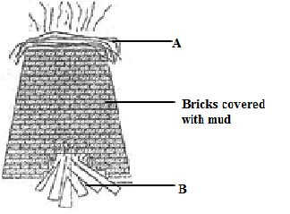

1. Name parts marked A and B

A_______________________________________________________________

B_______________________________________________________________

1. Why are bricks covered with mud before burning the bricks?

______________________________________________________________

1. Why do people do the above practice in the diagram to bricks?

______________________________________________________________

1. ***Re-arrange the steps below to show proper ways of using a water closet toilet.***
2. Wash the hands with clean water and soap.
3. Wipe yourself, flash and put back the lid.
4. Lift the lid and sit on the bowl seat.
5. Defecate or urinate into the bowl.
6. ______________________________________________________________
7. ______________________________________________________________
8. ______________________________________________________________
9. ______________________________________________________________

**END**